23rd Annual Tumbleweed Music Festival
2019 Logo Contest

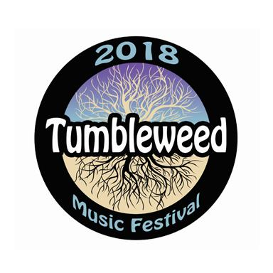
You can see your artwork or graphics on the internet, posters, T-shirts, buttons, fliers, and in print advertisements! The Tumbleweed Music Festival is seeking artwork/graphic designs to use in promotional materials for the upcoming 2019 festival, which will be held Labor Day weekend (August 30th, 31st, and September 1st) at Howard Amon Park in Richland, WA.

The theme for this year’s festival is “Power of Song”. The theme has been inspired by the life work of Pete Seeger, who would have turned 100 years old this year. The design does not necessarily have to relate directly to Pete, however, it should reflect the essence of the theme. Artwork will be judged on design quality, color, originality, ease of use on multiple graphic forms (T-shirts, posters, advertising), and how well it embodies the theme.

$150 WILL BE AWARDED TO THE ARTIST WHOSE DESIGN IS SELECTED.
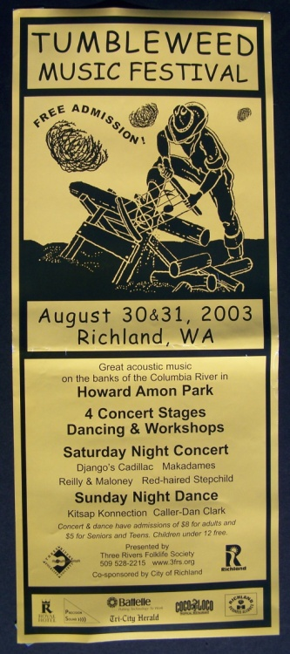
HOW TO ENTER

Anyone may enter - one entry per person.

DEADLINE: All logos must be submitted online by 11:59 pm on February 15, 2019.

SUBMIT YOUR ARTWORK:

By email: davidmcarson14@gmail.com
(Please put “logo contest” in the subject line).

By surface mail: to “Logo Contest,” PO Box 1098, Richland, WA 99352.

The image size of the file must not exceed 1280 x 1024 pixels. Please save the image at a resolution that will enable us to zoom in to see details during judging, but the file size must not exceed 5MB.

File formats: .gif or jpeg.

By submitting work and accepting the award, entrants acknowledge Tumbleweed’s right to reproduce images of their work and showcase the winner on Tumbleweed’s website, print materials, and related products at Tumbleweed events.

Tumbleweed assumes all entries are original and are the works and property of the entrant, with all rights granted therein. Tumbleweed is not liable for any copyright infringement on the part of the entrant and will not become involved in copyright disputes.

*************************************************************
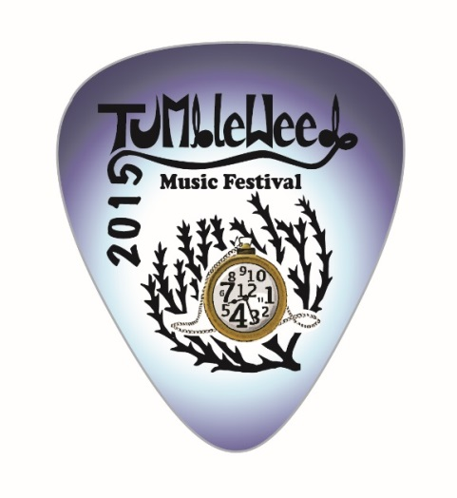
Submission Guidelines

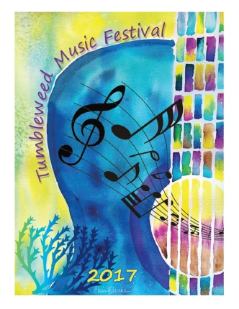
The purpose of the contest is to design a logo for the 23rd annual Tumbleweed Music Festival for 2019. The winning logo will be used online, in print, and on merchandise. Flexibility is a key requirement, including the ability to resize easily, and to look good in black and white as well as color. The final version of the logo will need to be suitable for high quality printing.

Entrants should take care to ensure that their entries are not in any way similar to existing logos or other copyrighted images.

The logo must also contain the phrase “Tumbleweed 2019” or the words “Tumbleweed Music Festival 2019,” and an image of a tumbleweed.

The Tumbleweed Music Festival is produced and presented by the Three Rivers FolklIfe Association - a 501(c)3 organization.

Representations and Warranties
By participating in the Contest, the Entrant warrants and represents in connection with the Entry submitted as part of his/her participation in the Contest: (a) he/she is the sole and exclusive owner of (and free of any adverse claim by any person, firm, or corporation) all intellectual property rights in and to the Entry; (b) the Entry is original and the use of the Entry as described in these Official Rules will not infringe the proprietary rights, including without limitation the intellectual property rights, of any third party; (c) the use of the Entry, as described in these Official Rules, will be in compliance with any third-party licenses pertaining to the Entry; (d) the Entry is not obscene or libelous, and does not violate any rights of any third party, including but not limited to rights of privacy or publicity; (e) the Entry does not contain any virus, spyware, malware, trap door, worm, or any other device, mechanism or code that is injurious or damaging to software or hardware used in conjunction with the Entry; (f) the Entry and its use as described in these Official Rules will not violate any federal, provincial, state or local laws or ordinances; (g) no employer or educational or other establishment has any rights in the Entry; (h) the Entry is consistent with these Official Rules; and (i) the artist has the right to grant the license to TRFS as required in these Official Rules.

Despite what may seem like lots of submission guidelines and all the legal mumbo-jumbo…we highly encourage you to submit your work!!! If we like it, we will gladly work with you.

